**Walk 47 Putley and Aylton**

Last walked in December 2016

**Description.** A 7 km (4.3m) easy walk with one climb into some woods. Going thru orchards, wood, field paths, country lanes and two churches. (This is an edited version of a walk in the Hereford Times in August 2011).

**Start.** Car park atPutley Green Post Office. Explorer map 189 652377.

**Directions from Whitecross Roundabout** (Turn milometer to zero). Take the A4110 Canon Pyne (Three Elms road) for 1 mile and TR at the traffic lights onto the A4103 Worcester (Roman road). After 7.7 miles TR, signposted to Stoke Edith. At 9 miles TL at road junction (not sign posted) onto main road to Ledbury. At 12.3 miles TR then immediately L signposted Putley Green. At 13.3 miles TR to park in the car park next to red telephone box at Putley Green.

**1. Putley Green Hall/Post Office. Putley is a small scattered village, rich in history. The little Putley church was largely rebuilt in 1875 by John Riley. The 14th century churchyard cross with its magnificent carvings is one of the finest in the county. Putley is famed for its beautiful apple orchards and is visited by many each year as part of the Big Apple festivities.** With your back to the car park, TR, pass the red phone box and walk along the road for a few hundred meters to reach a lone large house on the R called Abbots Place. Immediately past the house you bare R in front of Mill House and go down an enclosed track (‘Bad Boys Lane’). Continue straight ahead thru three gates at Putley Mill into an orchard. Go thru the orchard and thru an avenue to pass Putley Church and the pond (R) to reach a tarmac drive. Continue in the same direction, passing Putley Court (L) and straight on up to the road at the top. TL, after 25m TR and cross an awkward stile/gate onto a wide farm track that goes up an orchard to a wooden gate at the top L leading into a wood.

**2.**  **Gateway to Wood.** Go thru the gate and bear L and go up an obvious track. TL at the track junction/marker post and walk along a prominent track. TL at the next marker post and go down five steps into the wood. Bend R and follow a narrow path thru the woods to go down 20 more steps and on to reach the edge of the wood and road. TR, after 10m TL and go thru a small wooden gate in the hedge, down three steps and follow the aisle thru an orchard. Keep R of barns and go down towards a telegraph pole to reach a surfaced track and bear R, then L to reach the road at Upper House.

**3. Upper House.** TR and after 30m reach The Old Rectory, and (L of grid), go over stile into an orchard. Bear L thru the middle of the orchard and away from rectory conifer hedge, to reach the fence on the other side, and TR. After about 60m you TL and cross over a stile into the next orchard. TR, walk along the R edge and where the hedge starts to bend L, go R across a stile into the next orchard. Go ahead and where the next edge starts to bend L, go R over a footbridge and a stile into {F1}. Follow the R edge of the pasture for 130m to a marker post, where you TL. Walk across the middle of {F1} and on reaching the other side you TR and go thru a gate to continue along an enclosed farm track to reach the road.

**4. Road to Aylton Court.** TL, and continue along the road for about 1½ km, to reach a triangle and road junction. TR for “Ledbury five miles”, Aylton Court is on the R.

**5. Aylton Court**. ***On the 10 July*** ***1855, young Emma Foulgar was killed on the staircase in Aylton Court when her bother accidentally discharged a shotgun. Her body was buried in Aylton churchyard only to be stolen by body snatchers. Her ghost is said to haunt the stairway where she died to this day.*** Keep on along the road beyond the Oast House, old shack and pool and the road will bend L at Birchley. Further on the road veers R, and 200m further on you TL over a stile into {F2} (the stile is just before a drive to some farm buildings on the L, and before dwellings on the R). Walk along the R field edge of this large field, to cross a stile in the R corner and onto a road. TR, and walk for almost a km along the pleasant lane to Aylton. Reach hop kiln at Court Farm and Aylton church just beyond.

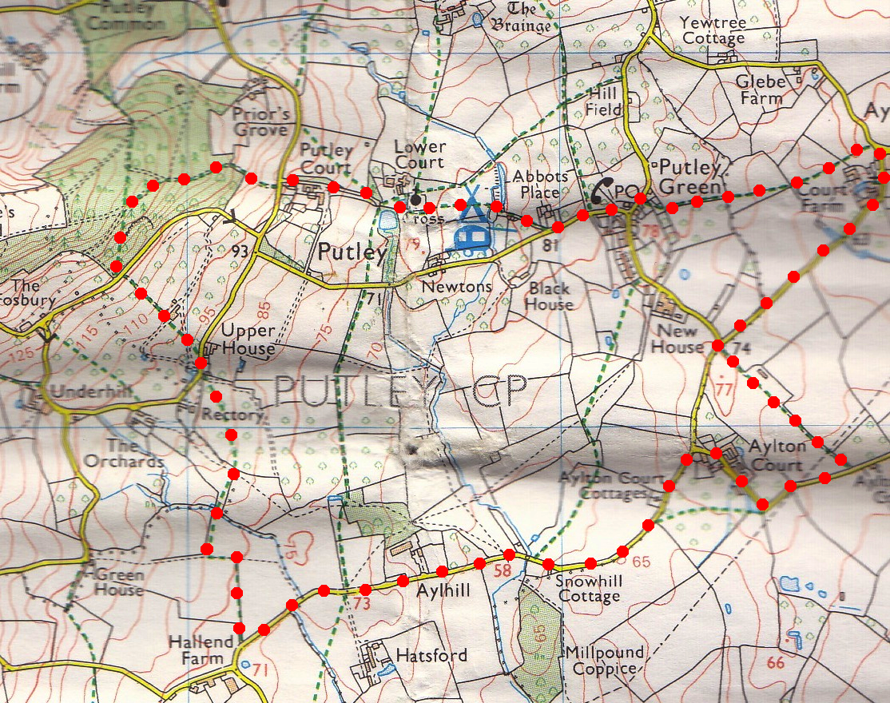

**6. Aylton Church. *The most delightful, simple church which has early 12th century origins. There was some updating in the 13th century. There are 2 bells, the larger of which is circa 1639, and the smaller is possibly 12th century - if this is correct it is one of only two of this date in Herefordshire. Aylton church is a very small church that does not appear to be dedicated to a saint.*** – visit the churchyard. ***There has been a settlement at Aylton since at least Saxon times, and the name Aylton is derived from name of the Anglo Saxon female leader of the settlement.***  Return to the road and TL, in your original direction, to reach the road triangle. TL for the Pool End and after a few paces, TL up three steps and thru a small metal gate into {F3}. Go across this field and thru a gate into {F4}. Go across this field and across a gated wooden footbridge into {F5}. Go slightly R ahead over further stile into an orchard and continue along the R field edge (hedge is on your R) to cross over a stile into a small orchard field. At the end you TR and go thru a gate and along a enclosed track, then thru a gate and onto the road. TL, go past The Homestead and TR (as if for “Putley Church”) and car park.

**6**

**5**

**4**

**3**

**2**

**1**